Charlie Lee **ICS3U3 Final Project (Design Document)**  ICS3U3

Ms. Kemp

Mon, Jan. 13th 2020

1. The purpose of this program is to entertain 2 users, who will verse each other in a dice based game. Yahtzee consists of 6 rounds for each category (get all 1’s, 2’s, 3’s etc.), with each player having 3 rounds to collect a total of 5 dice to keep. In each round, the player is allowed to either keep or discard up to 5 dice in their collection and at the end of 3 rounds, the next player’s turn will begin. The goal is to get a pattern (the same dice numbers for the particular category), which then will be converted into points at the end of the players turn. The larger the number on the dice’s face are, the more points you score (this only counts for dices that have the same number on them). The program will have a leaderboard (Player1/Player2 and a table of values showing underneath) that displays the players final score, as well as the category. It will also have a way to clear the discarded dice and a reroll system, for the empty indexes that the discarded dice left. It will also include a method that creates 5 square shapes that will be used to display and represent the dice’s numbers, using brackets (e.g. [5] [4] [1] [8] [2]). This program is used to entertain users who want a friendly competition. This could be used to wager which movies to choose, what restaurants to go to, etc. based on who wins. This game could also be used for plain old pure enjoyment or a way to kill time. This game is suitable for all age groups and anyone with friends/family that would want to kill time with a short and simple game.

2.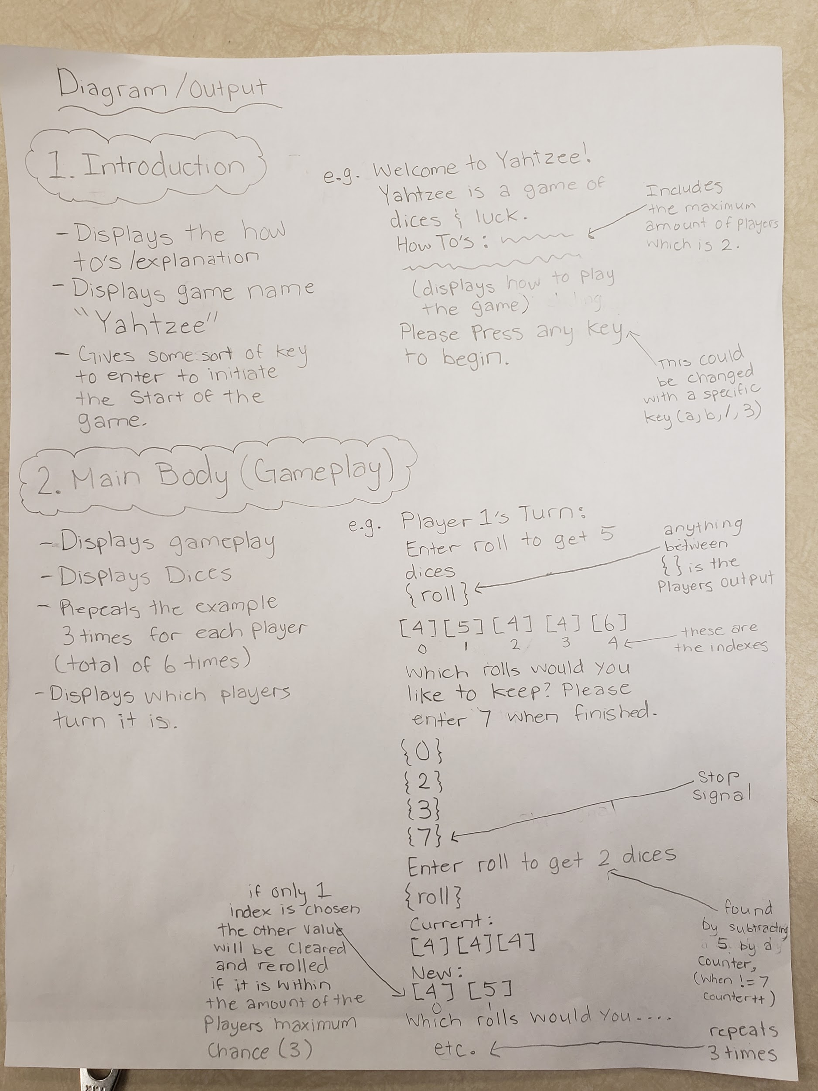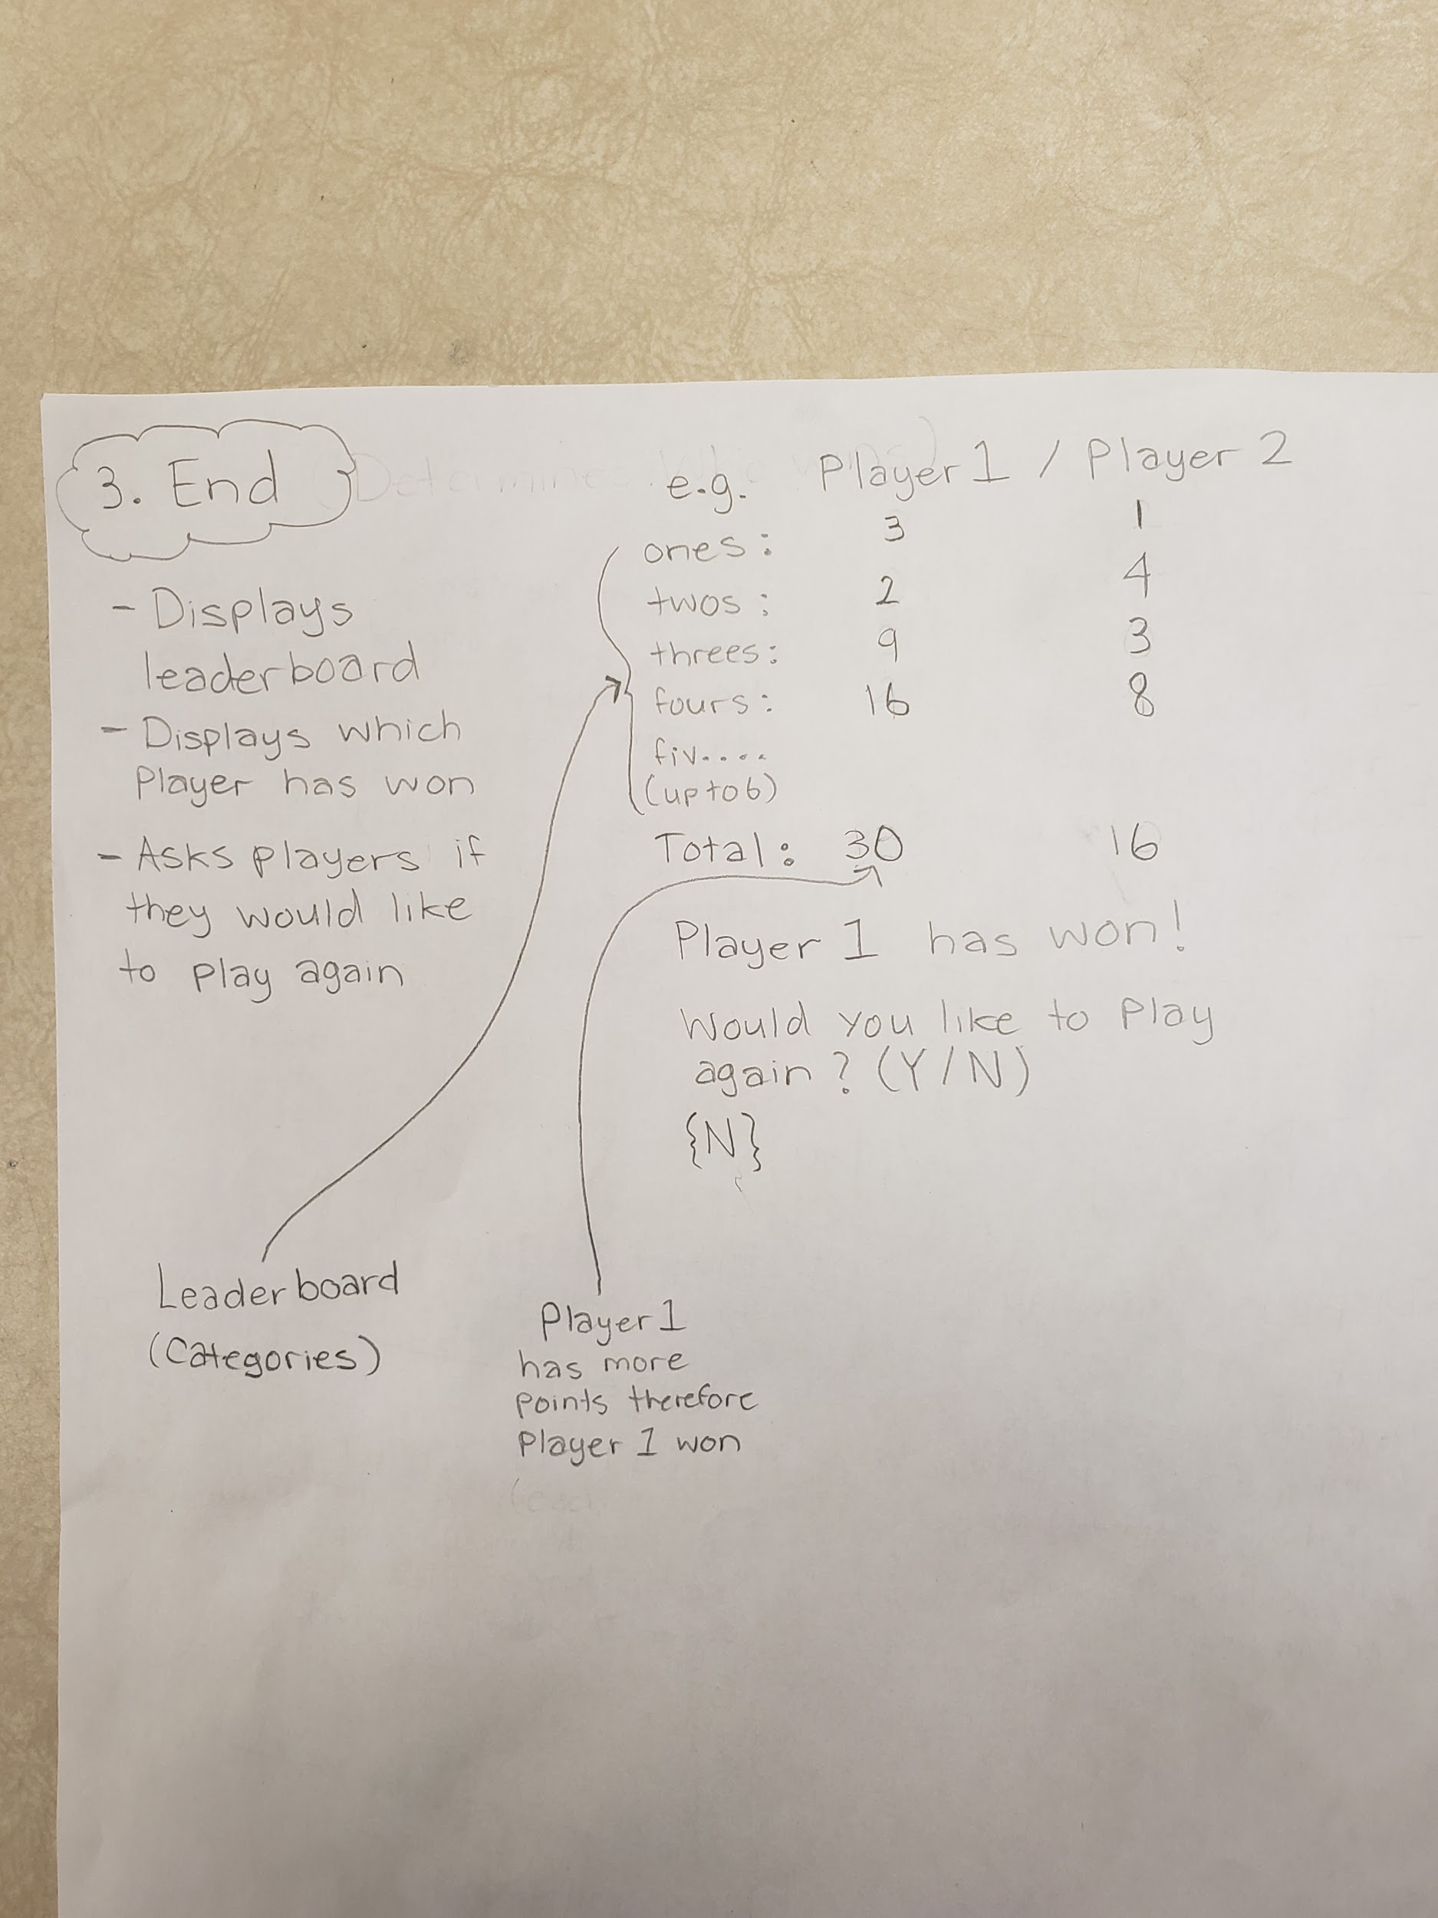

3. I would require 3 methods, one for rolling dice, another for calculating the points, and lastly one for

displaying the rolls.

public static void roll (int n)

This method is what generates the dice roll numbers. The method uses the pseudo random number generator (minimum is 1 maximum is 6, for dice) and adds it to an array list. This loops up to 5 times. (Initially it will do this 5 times but it could be less if the player decides to keep a rolled dice)

The return type is void and the parameter type is an integer.

public static int calculatedPoints (int[] dice)

This method calculates the points based on the keptDice array. The method has a for loop that loops 5 times and checks each number that is stored in every index, based on what category the game is currently in (Category for the same 1’s, 2’s, 3’s, etc.). This checks for the same numbers and calculates the points, the total amount of points is then returned to the main method.

The return type is int and the parameter type is int[].

public static void displayRoll (int arrayList)

This method displays the dice rolls that the player has rolled. The method loops continuously printing out the dice rolls in between [ ] from the stored info in the array list up to the total length of the array list.

The return type is void and the parameter type is int.

4.

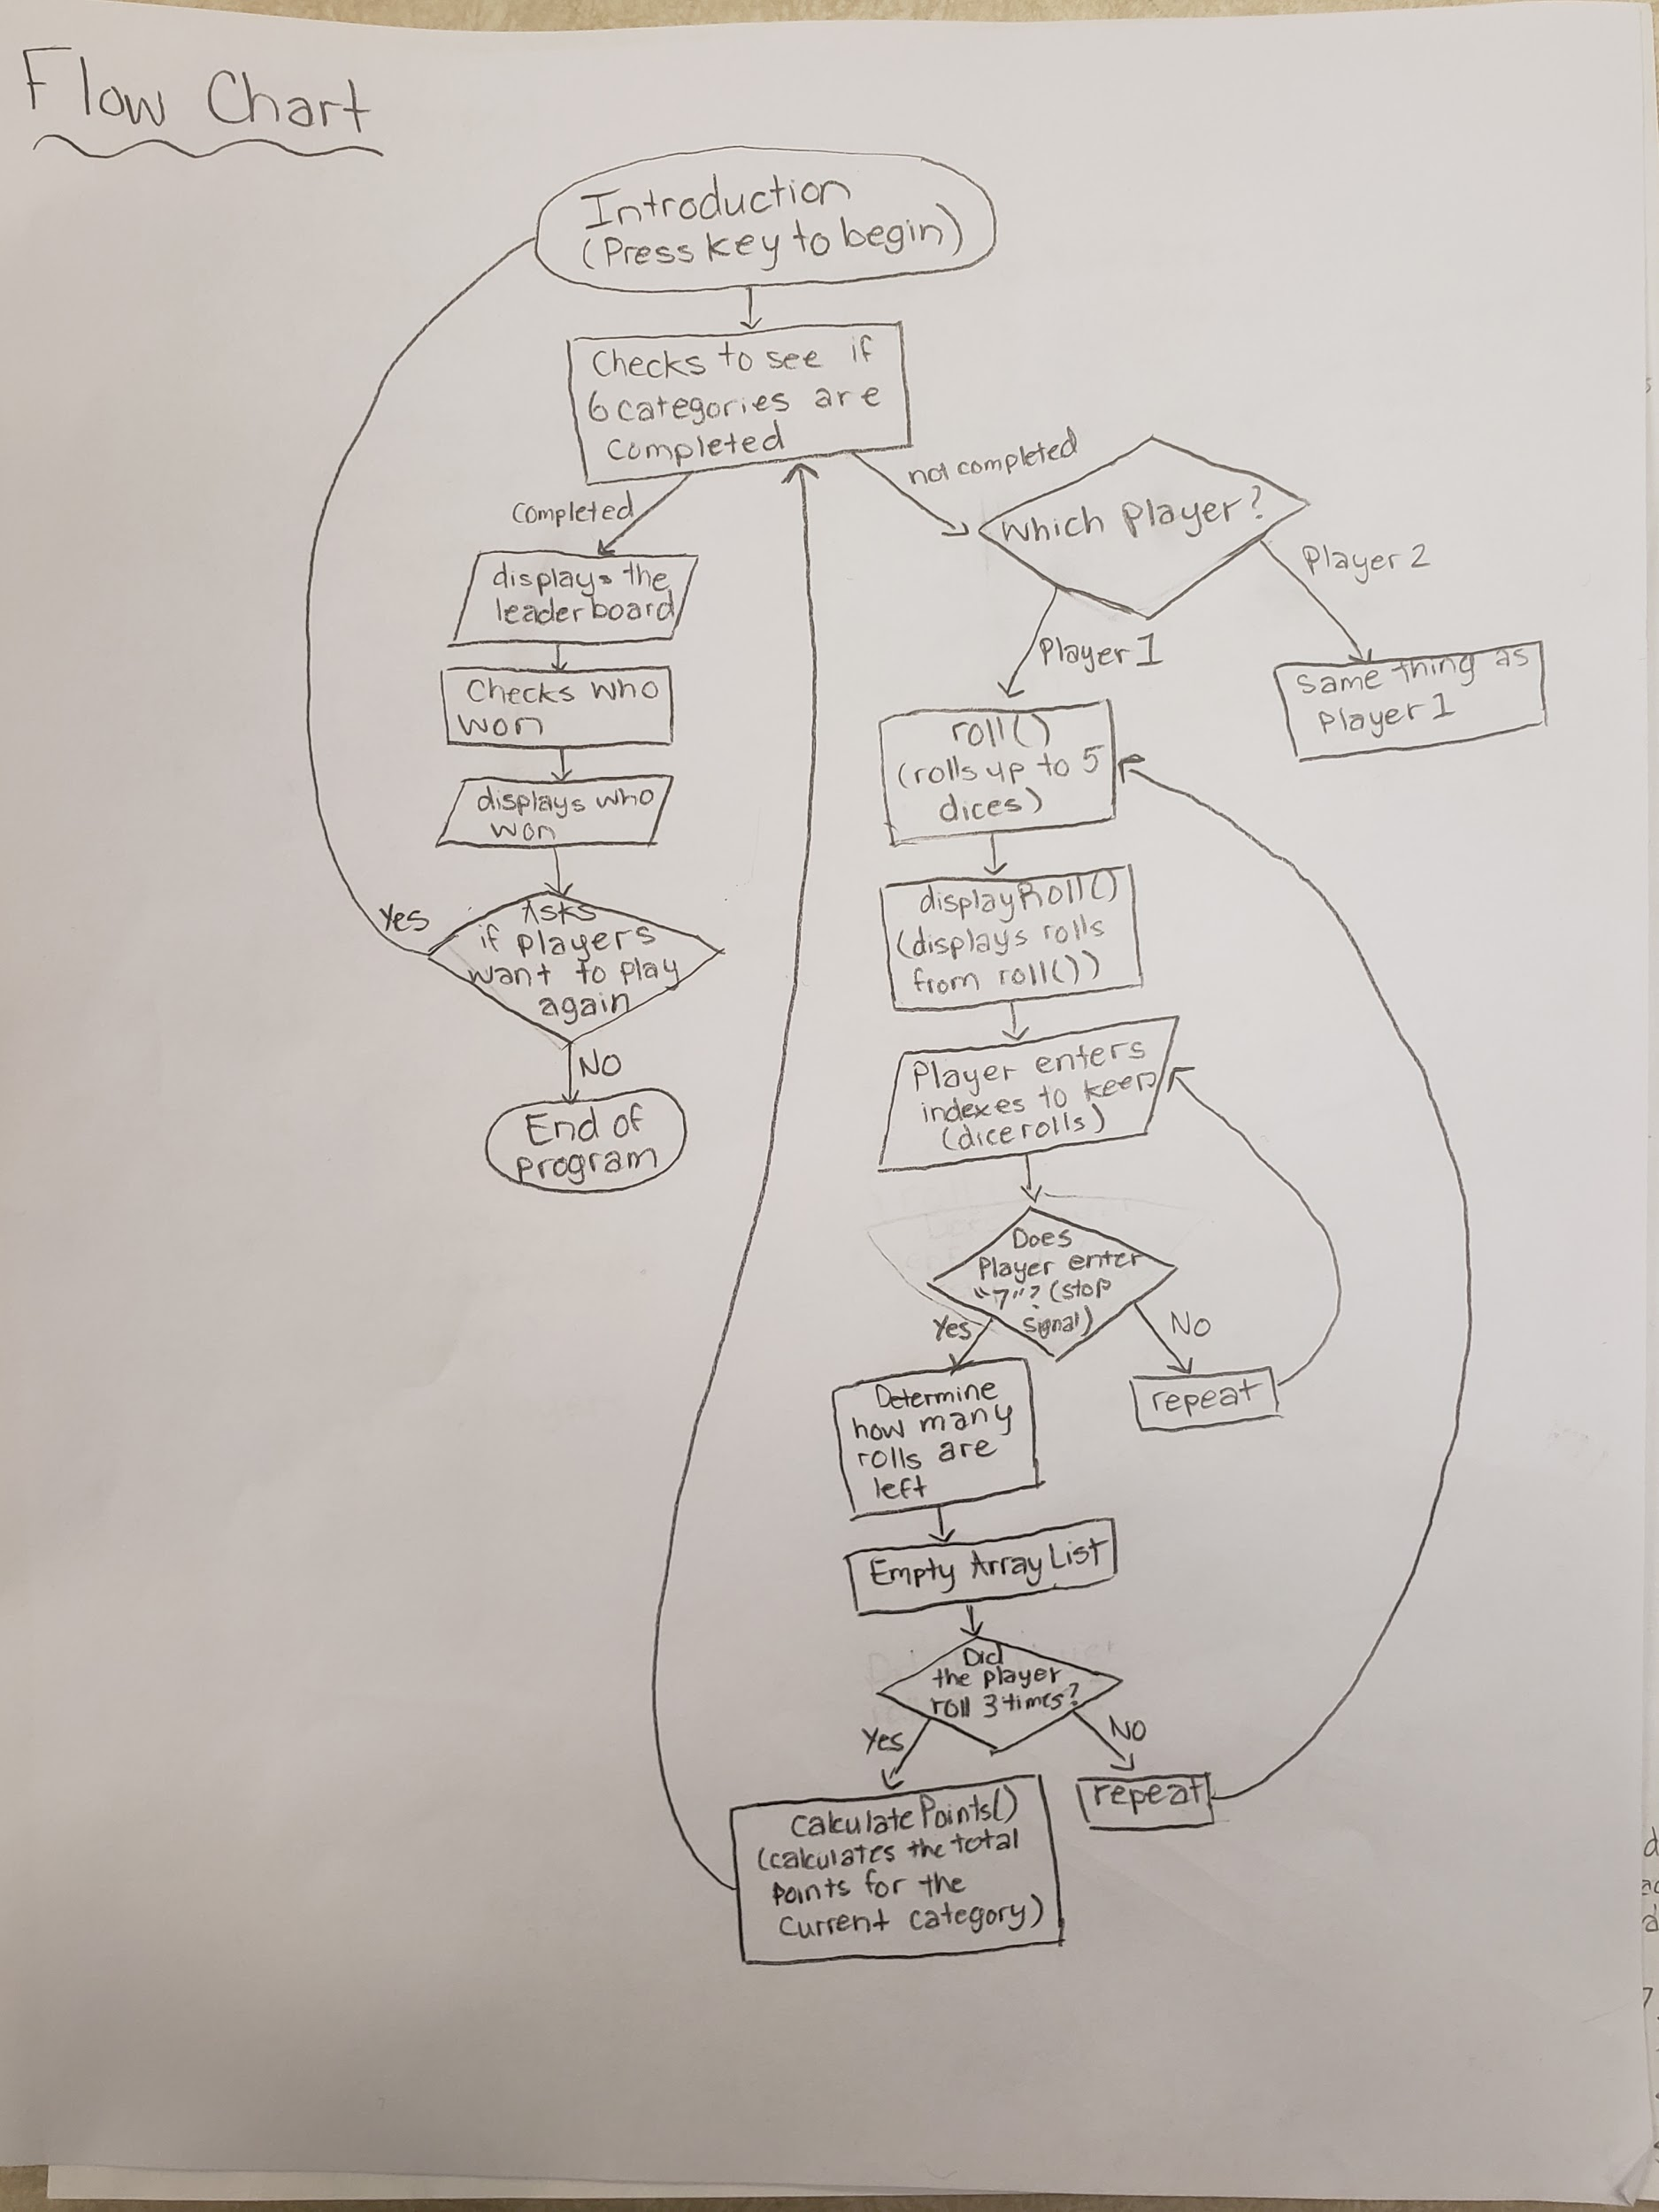

I would require 3 methods, one for rolling dice, another for calculating the points, and lastly one for displaying the rolls.

public static void roll (int n)

This method is what generates the dice roll numbers. The method uses the pseudo random number generator (minimum is 1 maximum is 6, for dice) and adds it to an array list. This loops up to 5 times. (Initially it will do this 5 times but it could be less if the player decides to keep a rolled dice)

The return type is void and the parameter type is an integer.

public static int calculatedPoints (int[] dice)

This method calculates the points based on the keptDice array. The method has a for loop that loops 5 times and checks each number that is stored in every index, based on what category the game is currently in (Category for the same 1’s, 2’s, 3’s, etc.). This checks for the same numbers and calculates the points, the total amount of points is then returned to the main method.

The return type is int and the parameter type is int[].

public static void displayRoll (int arrayList)

This method displays the dice rolls that the player has rolled. The method loops continuously printing out the dice rolls in between [ ] from the stored info in the array list up to the total length of the array list.

The return type is void and the parameter type is int.

Flow chart is on the paper given